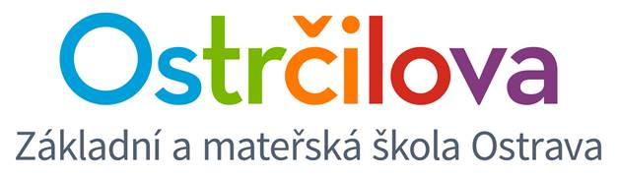

**NEWSLETTER No.2**

Dear parents, 22nd October 2018

This school year is in progress. Autumn is underway and Christmas is just around the corner. ☺

I would like to inform you about some important events:

**1.** On Friday 26th October we will celebrate **100th anniversary of the foundation of the Czechoslovak Republic**. If you feel like coming, you can take part in the event held by the city authorities (see <http://ostrava100.cz/calendar/ostrava-slavi-100-let-republiky/> )

**2.**There will be an **Autumn Break** from 29th to 30th October. The school will be closed.

**3.**On Wednesday 31st October we will celebrate **Halloween** with kids**.** We will study according to the schedule. The teachers will prepare many activities connected to this Anglo-Saxon feast. We will wear scary and funny masks. ☺ In the afternoon the Care centre educators will prepare a fun-filled afternoon. The kids will get more information from our educators. **Beware** of the fact that there will be no Athletics in the 7th lesson that day.

**4.**On Tuesday 6th November there will be Parents-teacher conference from 4 to 5:30 pm. Due to the fact that more teachers are teaching in many classes, you will be informed about your kid´s marks and his/her short assessment in Bakalari or by e-mail in advance. Those parents, whose kid has any problem, will definitely be invited to the conference by the teachers. In case, you are satisfied with the Bakalari comment on your kid´s school results and behaviour and you do not have any other questions, you do not need to attend the Parents-teacher conference.

**5. Information for 5E1, 5E2 a 7E:**you will find a questionnaire attached. It is an important source of information for us, mapping who is going to leave our school and who is going to continue his/her studies here. Please, hand in this questionnaire no later than 6th November 2018. Then we will go through these questionnaires and let you know with the final results and the following steps. Please, bear in mind that the class can proceed to another grade with the minimal number of 18 students.

**6.** On 6th December there will be a spectacular Christmas event called **Angel fair** in the afternoon. You will get more information later on.

**7.** At the moment we are waiting for the competition concerning the **Winter School Camps**. The camp of class **7E** will be organised at some point between January and March 2019, classes **4E1 and 4E2** between January and April 2019. Other bilingual classes will take part in the **ski courses** on a daily basis between January and March 2019.

**8.** Soon you will be informed about **the Language trip to Great Britain**, which has been organised for the students of 5E1, 5E2 and 6th to 9th graders. So far we have received a large number of application forms, which have been numbered. We have been looking for larger bus with high capacity for more students (about 64). The students with the number bigger than 64 will be alternates then.

**On behalf of the whole bilingual team**

Mgr. Kateřina Švejdová, M.A.