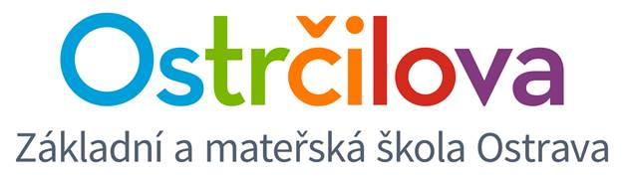

**NEWSLETTER No. 8**

June 13th, 2018

Dear parents,

You will find some information about the last days of June and the beginning of the school year 2018/2019 attached:

* As you know, the school **playground** has been under reconstruction since 4th June and **is** **not open to public**.
* Owing to the **hot weather and the heat** on the 4th floor, please dress the kids lightly (no trousers, socks or trainers). Our teachers watch the right water intake. At the moment we are doing the best to buy new fans to help it. Unfortunately, nobody will pay new roof insulation. Air-conditioning is too expensive – both the purchase and the electricity consumption (moreover it is not very healthy).
* **GDPR** – since the new law (GDPR) has come into effect 25th May 2018, we have sent various forms considering the approvals. It is quite annoying both for you and for us too, nevertheless we need to cope with it. ☺ I can ensure you that all the information of your kids are in good hands.

I would like to inform you that those who disagree with the approval considering the registry office, they should actually not be attending our school.

If you disagree with the fact that the school uses your e-mail address, then you must obtain the information we send in any other way (i. e. with the help of the other parents or your kids).

* **The last week of school (25th to 28th June):** we´ll have a short day (1st to 5th grades till 11:40, 6th to 9th grades till 12:35). The care centre will be operating.
* **Report cards:** on Friday 29th June from 8 to 8:45. Then there are no lessons, the care centre will be operating.
* **First day of school year 2018-2019:** on Monday 3rd September 2018 from 8.00 to 8.45. The care centre **will not** be operating that day.

I wish you great summer and a lot of rest on your holiday. Enjoy the free time, recover your strengths to the new school year which is just round the corner. ☺

I would like to thank my colleagues very much for their hard and above-standard work, their zeal and untiring vigour.

Mgr. Kateřina Švejdová, M.A.