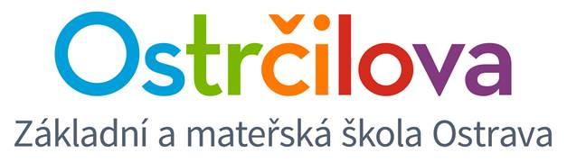

**NEWSLETTER No. 7**

Dear Parents! March 9th, 2018

Enclosed is some information about the following days:

1. **Spring Break:** March 12th – March 16th. The school will be closed. We wish you all lots of sleep and sunny days. ☺
2. **Saint Patrick:** We are going to celebrate it on Monday 19th. Please make sure that your child will come to school dressed in green as much as possible. ☺ Thank you for your cooperation in advance.
3. **Welcoming the Spring:** On Wednesday March 28th we are going to have a project day Welcoming the Spring. We are going to say goodbye to winter and celebrate Easter. Please make sure that the children will come to school dressed in spring colours. ☺ Thank you for your cooperation in advance. The project day will be in the morning, after lunch we will study according the schedule.
4. **Cambridge Exams (does not involve Grade 1 pupils):** You can get all the information about how to apply at our web pages. The English teachers will let you know how the children scored in our CE pretests. The official exams will be held in our school, but if having any questions about logging etc., please contact directly Cloverleaf language school.
5. **Time Change:** Sunday, March 25th

On behalf of the whole bilingual team,

Mgr. Kateřina Švejdová, M.A.