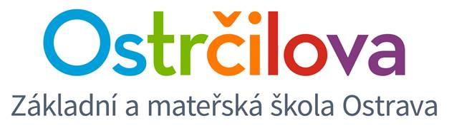

**NEWSLETTER No. 6**

Dear Parents! January 23rd, 2018

Enclosed is some information about the following days:

1. **OPTIONAL AFTER-SCHOOL ACTIVITIES**

**On Wednesday January 24 (i.e. tomorrow from 5 pm)** you will be able to sign your child to an optional after-school activity for the second term through the school web. Hopefully you will be pleased and satisfied and the enrolment will take place in peace. ☺ If there were any technical problems, we ask you for benevolence and understanding. We thank you very much in advance.

**The new after-school activities will start from Monday 29th, 2018,** however the change of the school schedule will start from Monday 5th, 2018 – which is valid for 2E1, 2E2, 3E1, 3E2 and 4E2.

Enclosed you have received the offer for the optional after-school activity. Tomorrow you will receive the rules and the instructions how to sign for them.

**Compulsory after-school activities** (Extra English, Starters, Movers, Flyers, Science, Maths, Spanish) are not offered as they will continue.

**All the children who attend our care centre MUST sign for the optional after-school activity,** for others it is a matter of choice.

1. **REPORT**

On Wednesday 31st, 2018 the children will receive their **non-official report.** This certificate is for you to keep. At the end of the school year the children will receive their official Czech report, English evaluation and their self-evaluation.

**The school finishes for 1. – 5.E at 11.40, for 6.E at 12.35 on that day.** The care centre will be operating as usual.

1. **HALF-TERM HOLIDAY**

The children are having a day off the school on Friday, February 2nd. The school will be closed.

1. **SCHOOL BALL**

We would like to welcome to our School Ball, which takes place on Friday, February 9th from 7 pm at the club Alfa on 3183 Veleslavinova Street in the centre. You can get the tickets and reserve your table at our reception downstairs.

On behalf of the whole bilingual team,

Mgr. Kateřina Švejdová, M.A.