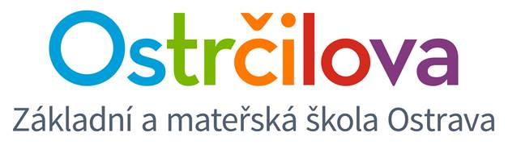

**NEWSLETTER No.4**

Dear Parents! October 23rd, 2017

**Enclosed is some information about the following days:**

1. **Wednesday 25th** – please make sure that the children will come to school dressed in colours of the Czech flag (blue, white and red) as part of our project day for October 28th. It does not involve 6.E class.
2. **From October 26th until October 29th** there is going to be autumn holidays. The school will be closed. **The time changes on Sunday 29th at 3 am.**
3. **Monday 30th** – Halloween Day. Please make sure that the children will come in a costume. We will teach according our schedules.
4. The date of **the parent-teacher conferences** was changed to Tuesday **November 14th.**  Class 5.E will have a group meeting at 4 pm.
5. **On Thursday November 23rd, Thanksgiving Day,** there are going to be open lessons (8.00 – 10.45) for parents of our bilingual students. You will receive more information at the beginning of November.

**A few organizational things about running the school:**

1. **Library – new time schedule**

Monday and Wednesday 🡪 small break between lesson 5 and 6

Thursday 🡪big break from 9.20 – 10.00

1. **The end of the lessons**

Please respect our rule and do not enter our 4th floor before the ring bells.

1. **Morning school arrival**

Please teach your children to come to school on time. **According our school rulers the children must be prepared for their lesson at 7.55.** Each late arrival is a distraction. If we lose 5 minutes every day from a lesson, it makes about 16 lessons per school year. ☹ The children, who are late, will receive a reminder. Even us adults need to be at work on time.

On behalf of the whole bilingual team!

Mgr. Kateřina Švejdová, M.A.