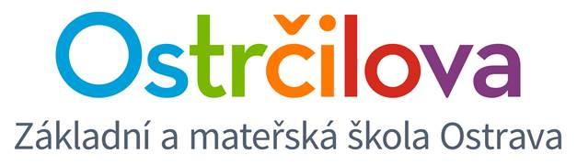

**NEWSLETTER No.3**

Dear Parents! October 5th, 2017

The school year has finally started. Let’s hope it is going to be an easy one. ☺

**Enclosed is some information about future school activities until the end of the year 2017:**

1. **At the end of October** there is going to be the **Halloween Day** for the children, so you can get their costumes ready. ☺
2. **On Thursday November 23rd, Thanksgiving Day,** there are going to be open lessons (8.00 – 10.45) for parents of our bilingual students. If you can spare your time and come to see your child in an action, it will be awesome.
3. **On Friday December 8th,** there is going to be the Christmas Market in the afternoon for our whole school.

Later on you will receive more information about each event.

**And now some information about organizational issues about running the school:**

1. **Report Books –** please check them at least once per week.
2. **Library –** Ms. Regina will hand out the books each Monday, Wednesday and Friday between lesson 5 and 6.
3. **Care Centre and Afternoon Club (odpolední herna):** enclosed there is the list of the children signed in those activities. There are 5 departments: Ms. Hanka, Ms. Klára, Ms. Jana, Ms. Regina and Ms. Lucka.
4. **Thank you for respecting our rule and not entering the 4th floor in the morning.**
5. We would like to ask you to wait to pick up your children until after the bells rings for the end of the lesson. If you get to school earlier, we do ask you on behalf of the entire school management, to wait downstairs at the reception. There are no classes so you will not disturb anyone. On our 4th floor there are classes and we also run an individual reading programme which is held in our hallway and unfortunately your presence there is disturbing. Thank you very much for your understanding and cooperation.

Thank you on behalf of the whole bilingual team!

Mgr. Kateřina Švejdová, M.A.