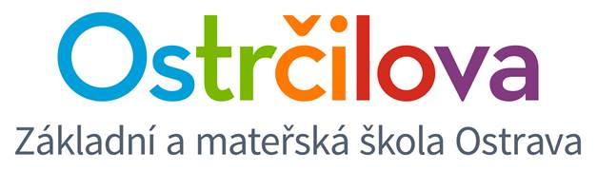

**NEWSLETTER No.2**

Dear Parents! September 11th, 2017

I am sending information about the schedules and the after-school activities offer.

Due to the absence of our native speaker, we had to do some changes in our schedules. Once the native speaker will get to school, we are going to make some following changes about which you will be informed. Please make sure that you write the schedules into the children’s report books with a pencil or a rubber pen.

**RULES – How to sign in for an optional after-school activity:**

1. You may enrol your child (noticeboards on the 4th floor) **from Wednesday, September 13th, 2017 7:40 a.m.** The enrolment will be finished **by Thursday, September 14th, 2017.** Grade 1 pupils do not sign for any activity this first semester.
2. Grade 2 pupils need to be enrolled by their parents. Other children will be helped by their class teachers if necessary. The fewer the adults in the 4th floor corridor, the better the safety and health of all of us ☺.
3. The activity will be started when at least 10 pupils are enrolled.
4. Please respect the number of places in the activity. If you write your child´s name below the line anyway, he or she may be considered a stand-in, but it may happen that they won´t be admitted after all.

Thank you on behalf of the whole bilingual team!

Mgr. Kateřina Švejdová, M.A.