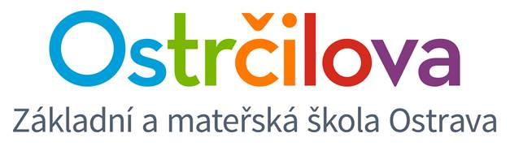

NEWSLETTER No. 9

Dear parents! April 10th, 2017
Let me once again remind you of our common Easter Coffee Morning on the 12th April 2017 from 8.00 to 10.45.
Please, bring some refreshments to share in our Easter Buffet. We will provide you with drinks, the kids should bring their own drinks as usual though.
We have already asked if one adult could accompany one child. This is particularly important with the little ones, the older ones could cope somehow , we believe.
From 8.00 activities in each kid´s own classroom will take place, after that you will have the opportunity to visit other classes and attend the workshops there too.
At 10.30 Easter Hunt is going to start . In case of bad weather this event will take place indoors only after lunch - without the parents then.
It will be great if kids could dress up to Easter or spring costumes on this day (bunnies, lambs, flowers, animals atc.). Even you, parents, may help supporting the Easter atmosphere by wearing a costume too. We - teachers - will be dressed up as well .
Best regards,
Mgr. Kateřina Švejdová, M.A.
P.S. 1 Tuesday, May 9 will be a Sports Day at the bilingual school. Please, provide your child with a white T-shirt on this day. Thanks a lot in advance!
P.S. 2 On April 26, the Czech Television is going to shoot a dancing show named Rytmix in our school. The children will learn the dance in the Care Centre and in the Playroom. If interested, pupils may also learn the dance at home - just by clicking on https://ulozto.cz/!EhY5xg4mHEku/twist-it-ray-charles-mp4
password: rytmix

You may also watch the previous parts of the programme on
http://decko.ceskatelevize.cz/rytmix

