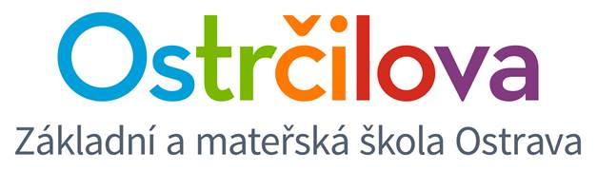

NEWSLETTER NR. 8

Dear parents! March 31st, 2017

Let me greet you all in this spring time. I hope you are getting accustomed to the change of the clock.
I have a couple of important pieces of information for you:

1. Until April 4 you can still enrol for the Cambridge YLE exams (taking place on May 20, 2017) or KET, PET, FCE (taking place on May 26, 2017)

2. Let me remind you that on Wednesday, April 5 there is Mgr. Nytra´s lecture on the topic bilingual education. There are still some vacancies. We´ll start at 16.30 in class 4.E.

3. Easter Coffee Morning for classes 1. – 5.E is going to take place on Wednesday, April 12. Parents or grandparents are welcome to spend a pleasant spring morning with us at school. Please, make sure though that just one adult comes around on that day since there´s a lot of us anyway . Spring workshops will start in each pupil´s own class at 8.00 and after that you will have a chance to visit other workshops too. Approximately at 10.00 we´ll start cleaning up the classrooms and at 10.30 Easter Hunt will start in the school yard. Afternoon lessons will follow according to regular schedule. We would kindly like to ask you if each child could bring something delicious to share on our Easter Table during the morning. Please, give your children their own drinks, we can provide the parents with coffee and tea.

4. Due to Easter Holidays there is no school between April 13 and April 17.

5. On Tuesday, April 25 from 13.00 to 17.00 enrolment to next school year´s first grade classes is going to take place. Therefore, all bilingual classes´ lessons will end at 11.40. In order to keep the floor quiet we would appreciate if we could close down the care centre and the afternoon playroom on that day. If it is necessary for a child to stay there though, we will take them downstairs into the Czech care centre in the “krček” at around 12.15 – but there really can´t be many of them. We appreciate your understanding and cooperation – thank you in advance.

6. Congratulations to class 9.E which attended the TV show Bludiště!

Best spring regards from the whole team of bilingual school teachers.
Mgr. Kateřina Švejdová, M.A.

