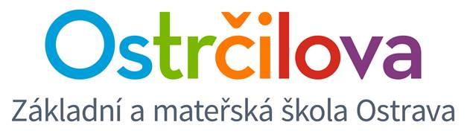

NEWSLETTER Nr. 6

Dear parents! December 21, 2016

We are approaching the end of year 2016. Let me and my colleagues from the bilingual school wish you all the best, especially peace and health.
Here are a few pieces of information for you:
- As you have already been informed, on Thursday 22 December, lessons will end earlier: first to fifth graders´ lessons end at 11:40, seventh and nineth graders end at 12:35. The care centre and the afternoon play club will be open until 17:00.
- The first day at school in the new year is Tuesday 3 January 2017.

WE HELP THE CHARITIES
The classes have decided do donate part of the money they earned during the Christmas Fair to the charity. We are thankful and very happy that they care about others too.
- Ms Synková´s dogs´ shelter in Heřmanice
Class 1.E2 donated 5 000 CZK to abandoned dogs and cats – food will be bought for this money. Other interested pupils have joined in too. Ms Synková was impressed by such an act, thanks very much and wishes a Merry Christmas to everyone.

- Hospital Clowning
We have managed to collect about 8 000 CZK for hospital clowning organisation (www.zdravotniklaun.cz). The hospital clowns will come to our school during the second term to give a lecture about their work. The organisation would like to thank very much to everyone who contributed with their money to this helpful and important activity.

- Plastic bottle caps collection for Maruška Kučerová
The care centre and bilingual classes have collected almost 12 sacks of the caps. On Thursday 15 December we gave Maruška and her mom symbolical 2 of those sacks and 1 200 CZK for the other 10 sacks (180 kg) of plastic bottle caps. The family spends the money on rehabilitation and treatment. We will be very happy if you keep supporting us in this project and put all the caps into the plastic box by the bookshelves in the corridor.
Best regards from the whole team of bilingual school teachers
Mgr. Kateřina Švejdová, M.A.

