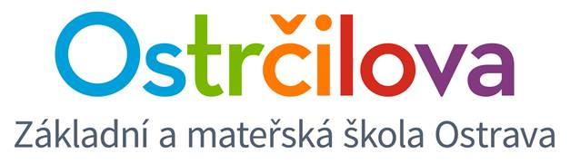

NEWSLETTER Nr. 5

Dear parents! December 2, 2016

Let us inform you in detail about the Christmas Fair (Jarmark), which will take place on December 8, 2016, 14:00 – 17:00.
- We will collect the Christmas sweets for the Galerie Café in the morning from 7:40 to 7:55 in the school basement. Thank you in advance for participation.
- It would also be nice if the children could bring their goods for sale in the morning and leave them in their classrooms.
- On this day, first to fifth grades will end their classes earlier than usual - at 11:40, seventh and nineth grade will end classes at 12:35. The care centre will be ready as usual, although we would be really glad if you could pick up your children right after the classes end, so we could start getting all the things ready for the afternoon. Again, thank you very much for understanding and cooperation.
- If the weather is friendly, the children will be able to do some roller skating on the rink in the school yard in the morning. There will be a chance for the children do try the roller skating in the afternoon as well (if there are enough people interested in it under the supervision of their parents.
- The fair begins at 2 o´clock. By the time you pick your child up, you take the responsibility for them.
- The event ends at 5 o´clock. A team of teachers and older students will need to get the school ready for the next morning again. We will welcome any help of the parents, especially fathers, with cleaning up the stalls.
- Ms Lenka needs small jars for her workshop. If you have any, please give them to your children – on Monday a box where we will collect them will be installed under the ping pong table.
- On Tuesday 6 December St Nicolaus, an angel and the devil will visit our bilingual school

This year´s last day of school - December 22, 2016
During this day Christmas activities will be taking place in classrooms. You will recieve detailed information from the class teacher. The classes will end earlier than usual on this day: first to fifth grade at 11:40, seventh and nineth grade at 12:35. The care center will be opened until 17:00.
Best regards from the whole team of bilingual school teachers
Mgr. Kateřina Švejdová, M.A.

